Southern Tier Chapter of
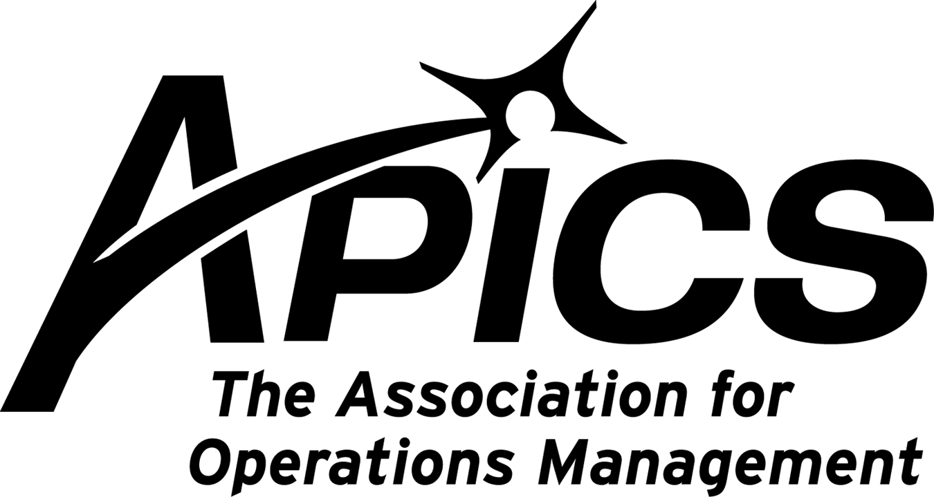
www.stapics.org

“Advancing productivity and innovation and competitive success.”

APICS & NAPM DINNER MEETING

Thursday, April 21, 2011

Location: Grande’s Pizzeria
1250 Upper Front Street, Binghamton

Guest Speaker:
Jason D. Tripp
Retirement Planning Specialist
AXA Advisors, LLC

5:30PM Sign-in and Networking
6:00PM Dinner
6:30PM Guest Speaker

Dinner: Order off Menu

Cost: Members $15. Non-members $20.
Excludes drinks

RSVP by 4/18/10 to Keith_Jamba@uhs.org or by calling 607-763-5138

Thanks and hope to see you there!

Come join the Board of Directors

Unlike some other organizations, the Board of Directors of your chapter is not self-perpetuating. We are always looking for new blood to reenergize us. We encourage you to join us in planning the trajectory of your local APICS chapter. If you’re interested, contact any member of the board. Why should we have all the fun?

APICS NorthEast District Student Competition -Resources
April 16, 2011 at Quinnipiac University, Hamden, CT

Competition Summary
A team comprised of four students will be presented with an operations management/ supply-chain case:
• Case is approximately 15-20 pages

• Students have four hours to analyze the case and create a PowerPoint presentation with their recommendations to Senior Management

• Students have fifteen minutes to present their solution to a panel of judges. (Judges are respected
professionals and senior corporate managers.)

• We are recruiting University teams from NY, NJ and New England

• Participation is limited to 24 teams
– 12 Graduate and
- 12 Undergraduate teams

Student Prizes
• 1st Place Team: $1,200

• 2nd Place Team: $800

• 3rd Place Team : $500

• 4th and 5th Place teams get APICS student memberships for one year.

*All winning teams may receive a one year APICS student membership.

More information will be posted at http://www.bostonapics.org/students.cfm


Sunday, April 24
Wednesday, April 27

2011 Volunteer Leadership Workshop (VLW)
Call for Papers

Submission Deadline: Saturday, April 30th, 2011

The 2011 Volunteer Leadership Workshop (VLW) is a day long training for APICS volunteers* held on Saturday, October 22nd prior to the APICS International Conference and Expo. The theme of this year's training will be Membership Retention and Strategic Planning.

The VLW Committee is presenting a Call for Papers for two tracks at this year's training. The criteria for submission are listed below:

1. The submission needs to be a success story with proven results-quantifiable performance measures to illustrate said results.

2. By April 30th, you must submit a rough draft PowerPoint presentation of 15-20 slides with the points you will be covering in your presentation. Length of presentation should be 45 minutes with an additional 15 minutes for questions from the audience.

3. Must follow Train the Trainer (TTT) guidelines for the PowerPoint.

4. List three events that you have presented at in the past two years.

5. Provide three references

* Volunteers of APICS include these channel partner leaders-chapter officers, district managers and support staff, students/scholars, international members, International Associates, and Authorized Education Providers.

Send your questions/submission by April 30th to the VLW Committee at: chaprel@apics.org

Volunteer Leadership Workshop Committee, 2011
Ione Dykstra, VLW Committee Chair and District Manager, Heartland District
Dave Johnson, Phoenix Chapter
Susan Neff, Memphis Chapter
Patricia Crotty, Dayton Chapter
Humphrey Vernaus, Winnipeg Chapter

C A R E E R O P P O R T U N I T Y

Customer Inventory Analyst position at MWV in Sidney, NY. Click on below to learn more.

Educational Opportunities!!!

The Southern Tier Chapter of
In association with


PRESENTS:

Supply Chain Management Excellence
Thursday, 28 April 2011, 9:00 AM to 3:30 PM
The McKinley on the Huron Campus (Endicott NY)
MUST REGISTER by April 15th!!

Click on below to learn more.

Seminar 1 Educational Conference / Expo and Lean Six Sigma Certificate Workshop
Conference: April 25 - 26, 2011
Lean Workshop: April 27 - 28, 2011

Holiday Inn Hotel & Suites
265 Lakeside Avenue
Marlborough, MA 01752
P 508-481-3000 F 508-357-8841

Click here for more information and registration

ISM's 96th Annual International Supply Management Conference & Educational Exhibit
May 15-18


Click here to register.

We’re on !!!

Come and visit, poke around, or comment on us! Our name there is “Southern Tier Apics”. It’s just another way
for us to keep in touch with our membership.

For the latest in chapter happenings check out WWW.STAPICS.ORG

Your 2010-2011 Board of Directors

President / VP Education Dave Gardner dgardner@akraturn.com
VP Membership / Website Lee Schechter lschechter@stny.rr.com
Executive VP / Director of Finance Steve Whited steve.whited@mwv.com
Director of Education Don Sheldon dsheldon@stny.rr.com
Publicity / Marketing / Programming Michael LoSapio Michael.losapio@synergyresources.net
Marketing Director Kelly Norieka Kelly.norieka@lmco.com
Secretary Deb Unkel deb.unkel@raymondcorp.com

Southern Tier APICS
PO Box 1107
Binghamton NY 13902-1107

